Derek Lee, Shine Li, Steven Li Computer Operating Systems Fall 2020

Professor Hakner PSET #2

**Test Case #1: /home**

Testing the program on /home directory

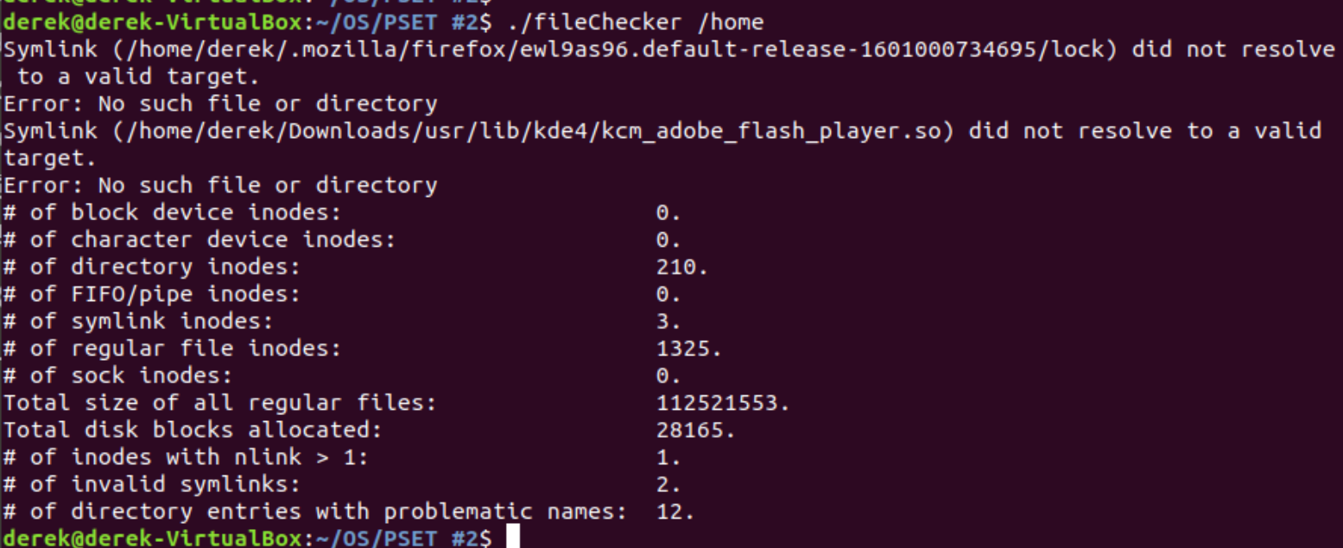

Figure 1: Reported results from running:  
./fileChecker /home

**Test Case #2: Root Directory**

Testing the program on the root directory. Many errors were reported.

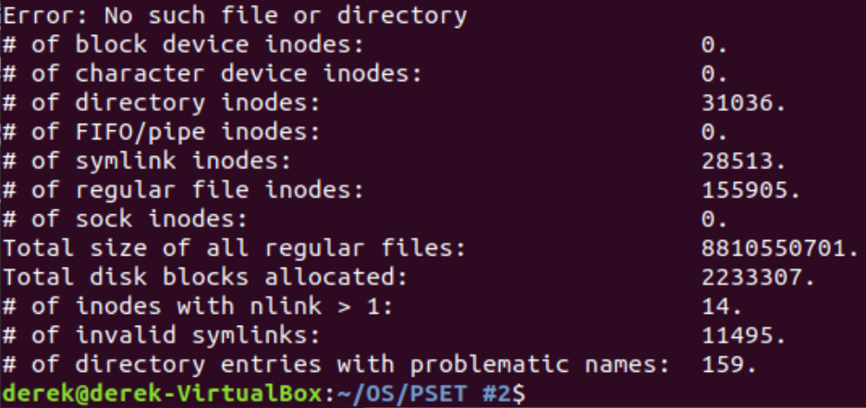

Figure 2: Reported results from running:  
./fileChecker /

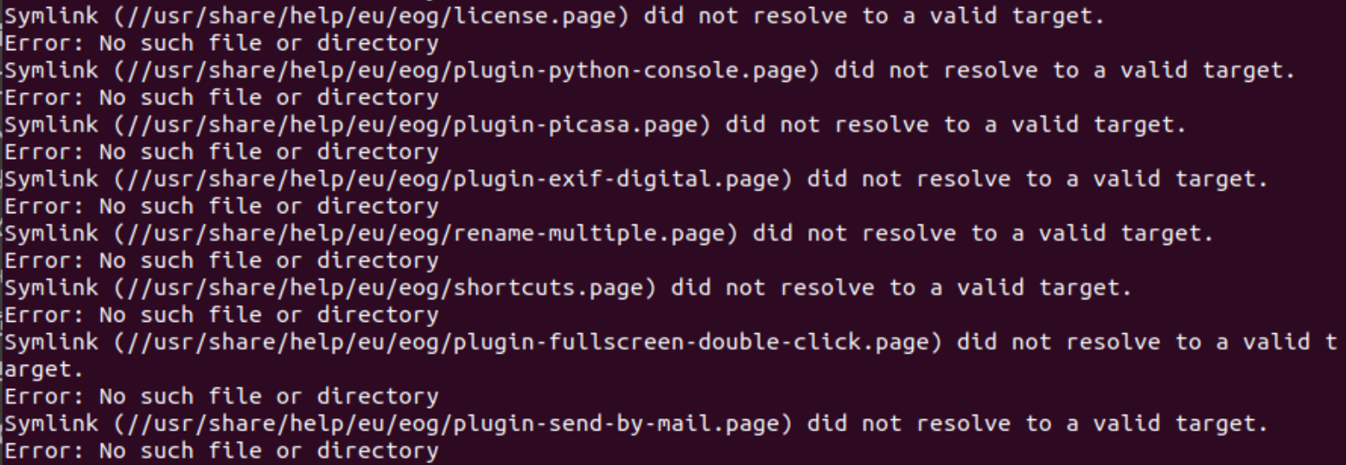

Figure 3: Example of errors from running:  
./fileChecker /

**Test Case #3: /dev**

Testing the program on /dev directory. This directory contains block and character device inodes.

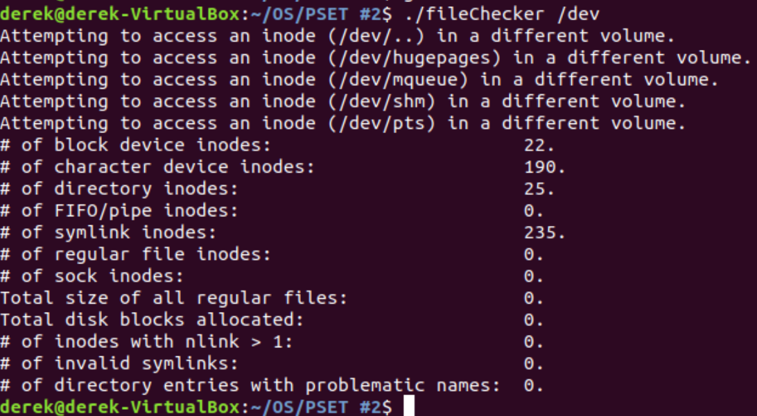

Figure 4: Reported errors and results from running:  
./fileChecker /dev

**Test Case #4: No arguments**

Testing the program when given no arguments.



Figure 5: Reported error from running:  
./fileChecker

**Test Case #5: Invalid path**

Testing the program when given an invalid path.

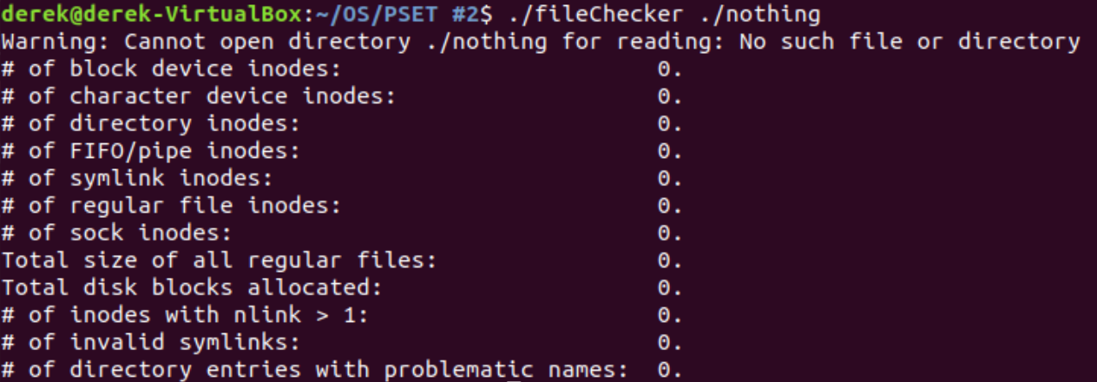

Figure 6: Reported error and results from running:  
./fileChecker ./nothing

**Test Case #6: Looped Symlinks**

Testing the program on a directory with looped symlinks.

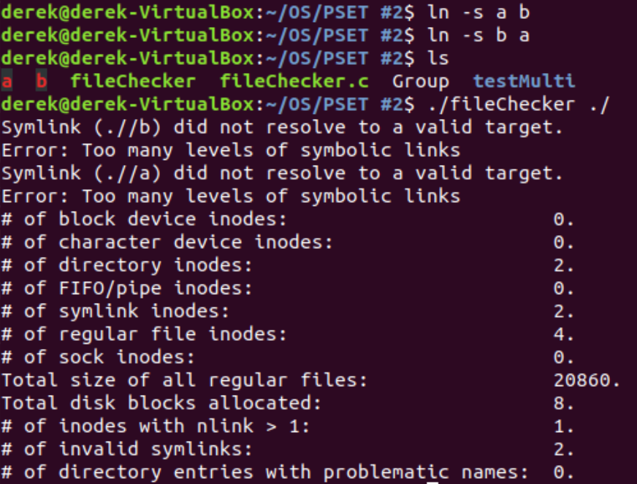

Figure 7: Reported error and results from running:  
./fileChecker ./

**Test Case #7: Valid Symlink**

Testing the program on a directory with a valid symlink.

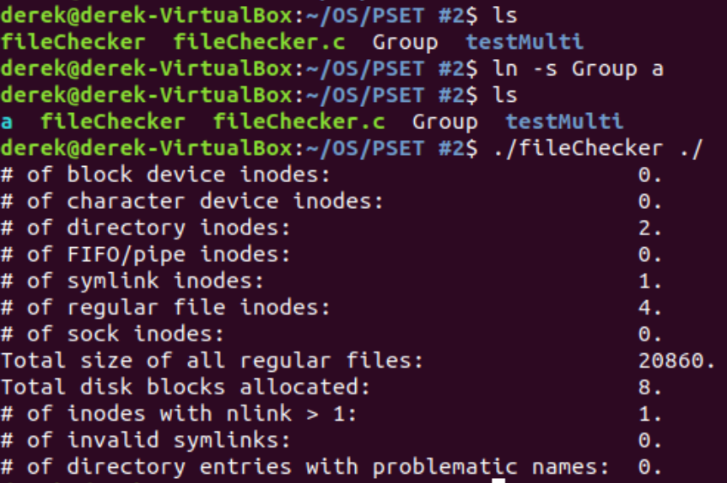

Figure 8: Reported results from running:  
./fileChecker ./

**Test Case #8: /proc**

Testing the program on /proc directory. This contains the enormous fake file.

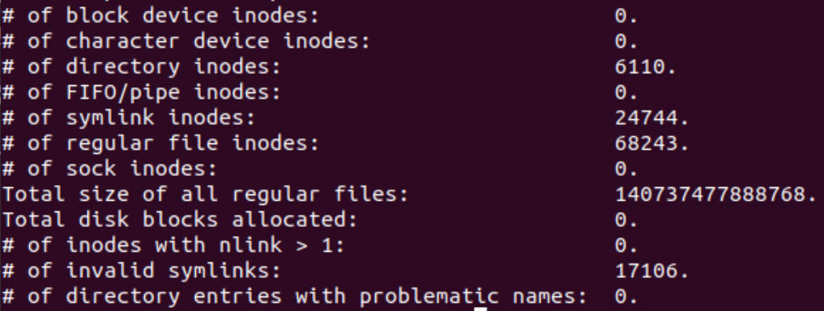

Figure 9: Reported results from running:  
./fileChecker /proc

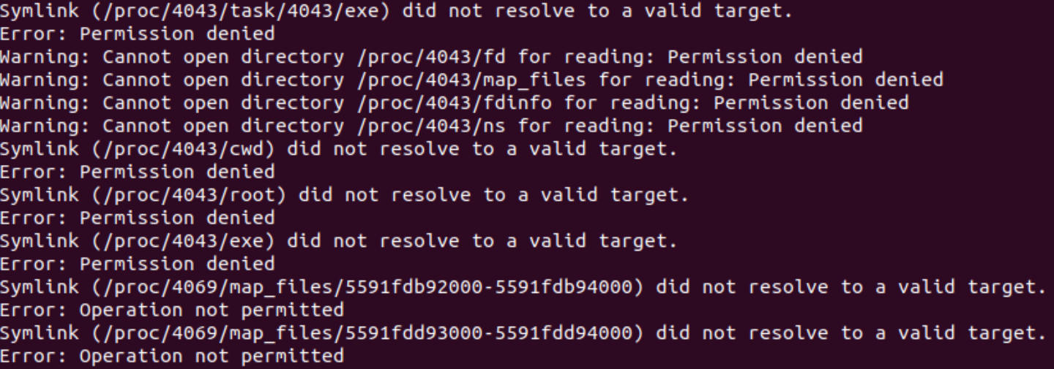

Figure 10: Example of errors from running:  
./fileChecker /proc

**Test Case #9: Multiple hard links**

Testing the program on a directory with a file with multiple hard links. It is only counted once.

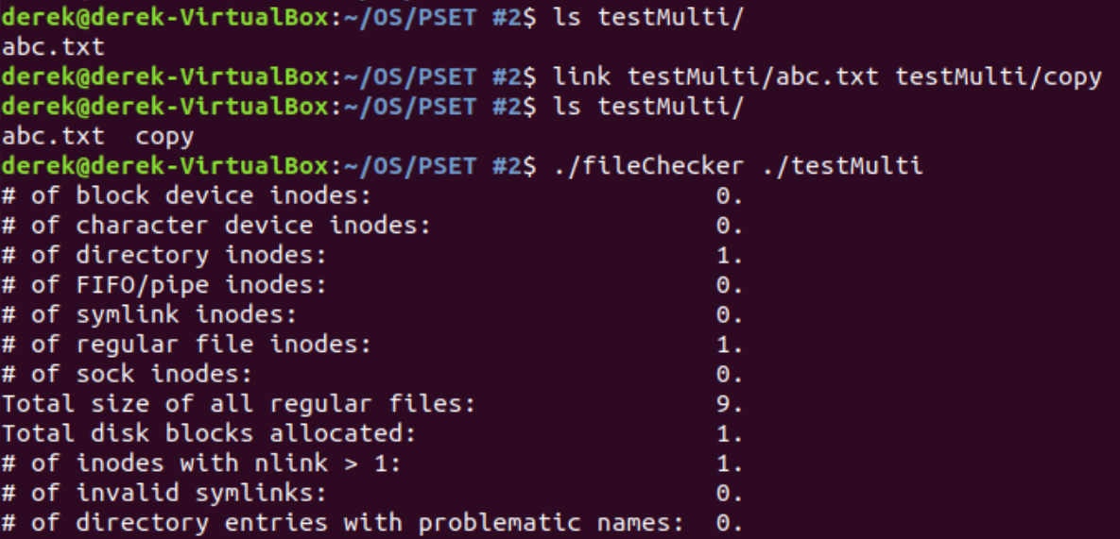

Figure 11: Reported results from running:  
./fileChecker ./testMulti